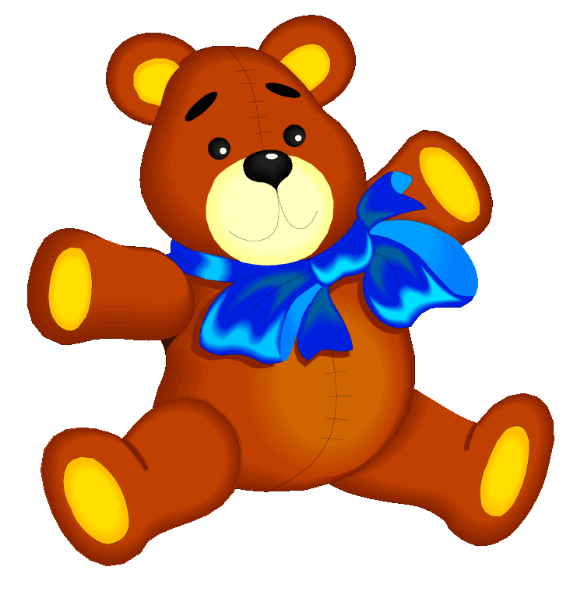
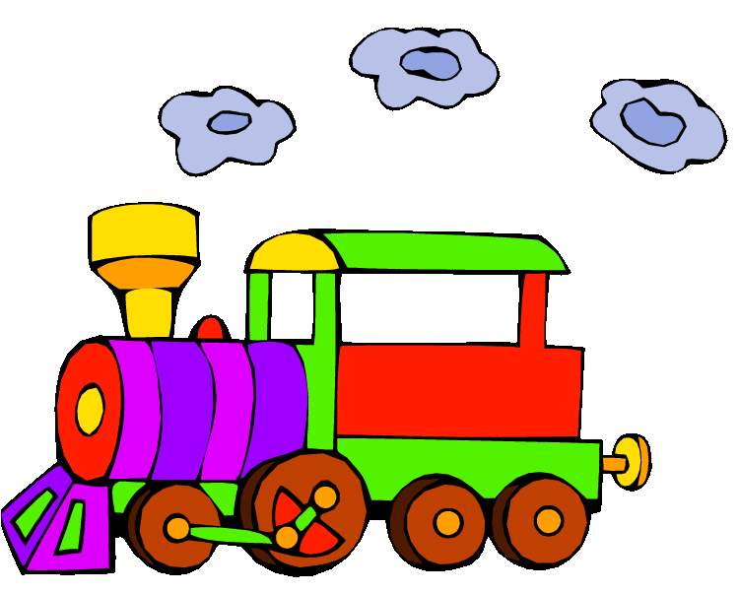
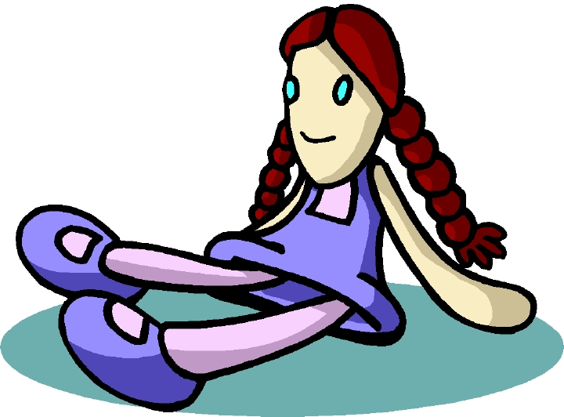
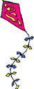
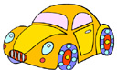
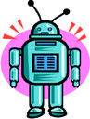
a teddy

a train
a doll
a kite
a car
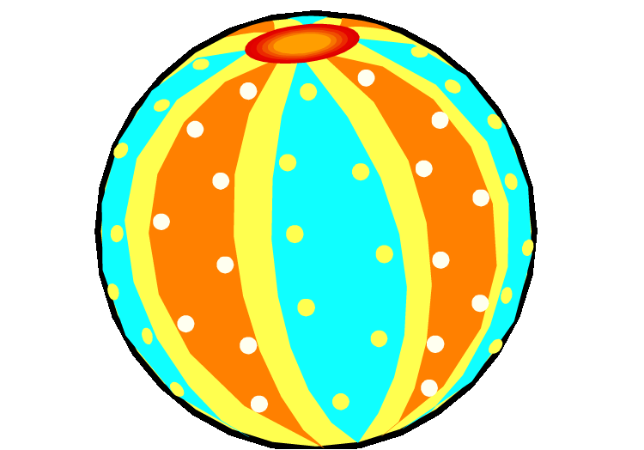
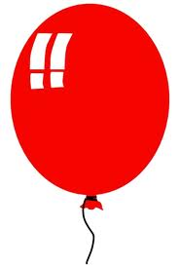
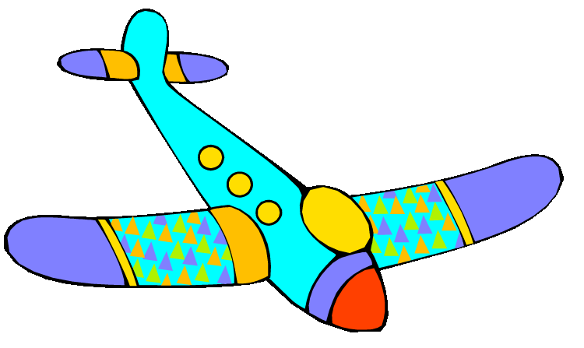
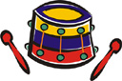
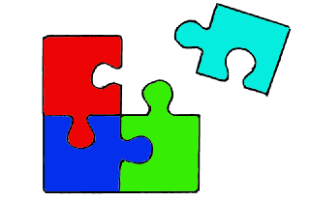
a robot

A balloon
a plane
a ball
a drum
a puzzle

Is it a teddy? Yes, it is\ No, It isn’t.
Is it a car? Yes, it is\ No, It isn’t.
Is it a train? Yes, it is\ No, It isn’t.
Is it a ball? Yes, it is\ No, It isn’t.

Is it a kite? Yes, it is\ No, It isn’t.

Is it a puzzle? Yes, it is\ No, It isn’t.
Is it a doll? Yes, it is\ No, It isn’t.
Is it a balloon? Yes, it is\ No, It isn’t.
Is it a plane? Yes, it is\ No, It isn’t.

Is it a robot? Yes, it is\ No, It isn’t.
Is it a drum? Yes, it is\No, it isn’t.
What is this?
What is this? It’s a _eddy.
What is this? It’s a _oll.
What is this? It’s a ball__n.
What is this? It’s a b_ll.
What is this? It’s a __um.
What is this? It’s a pu__le.
What is this? It’s a _ar.
What is this? It’s a __ane.
What is this? It’s a _obo_.
What is this? It’s a __ain.

